

An Iconographic Study of Xiwangmu during the Han Dynasty Author(s): Jean M. James

Reviewed work(s):

Source: *Artibus Asiae,* Vol. 55, No. 1/2 (1995), pp. 17-41 Published by: Artibus Asiae Publishers

Stable URL: <http://www.jstor.org/stable/3249761>

Accessed: 02/06/2012 17:42

Your use of the JSTOR archive indicates your acceptance of the Terms & Conditions of Use, available at <http://www.jstor.org/page/info/about/policies/terms.jsp>

JSTOR is a not-for-profit service that helps scholars, researchers, and students discover, use, and build upon a wide range of content in a trusted digital archive. We use information technology and tools to increase productivity and facilitate new forms of scholarship. For more information about JSTOR, please contact [support@jstor.org](mailto:support@jstor.org).

|  |  |
| --- | --- |
|  | *Artibus Asiae Publishers* is collaborating with JSTOR to digitize, preserve and extend access to *Artibus Asiae.* |

JEAN M. JAMES

AN ICONOGRAPHIC STUDY OF XIWANGMU  
DURING THE HAN DYNASTY

uestions about the origin and identity of the Chinese deity named Xiwangmu have provoked a number of studies by various scholars such as Homer H. Dubs, Michael Loewe, Riccardo Fracasso, and Wu Hung.' All of the above discuss the various pre-Han and Han texts describing Xiwangmu and, with the exception of Fracasso and Dubs, include images of her produced by Han artists. Dubs discusses some 24 textual descriptions, focusing on her role as a folk deity; images of her in late Han art are referred to but not illustrated, as being supplemental to the texts on which he concentrates. Loewe sees her as linked to the Han cult of immortality, citing relevant texts from many periods, including those written well after the Han dynasty ended in A.D. 220. For illustrations he has chosen line drawings of images from late Han pictorial stones from Shandong and a mirror back. Dubs, writing in 1942, and Loewe, writing in 1978, did not have the advantage of the many other images of Xiwangmu discovered by Chinese archaeologists in recent excavations.

Wu Hung, approaching Xiwangmu as an art historian, has relied on images of her as his primary sources, with the texts as supplemental. He reads her images in several ways, depending on the context in which they appear; she was a deity who ruled on Mount Kunlun, was linked to the cult of immortality, inspired devotion, and was prayed to for rescue in time of trouble. Her soteriological role was emphasized by Dubs who saw her only in that role. This is the role implicit in those images of Xiwangmu showing her *en face.* Wu Hung remarks further on her role in Sichuan as a granter of good fortune and on another role, along with her consort Dongwanggong, presented in Shandong, where the two deities take on a cosmic function as emblems of *yin* and *yang* respectively. Wu Hung's argument is the most complete art historically. Riccardo Fracasso deals only with texts and includes several not used by Dubs or Loewe. Images of Xiwangmu in art are not his concern.

The Xiwangmu we see in Han art does not fit all the descriptions of her in the texts. Even so, it is in early texts like the *Shan Hai Jing* that beliefs in her existence, who she was, and where she dwelt, were stated. We assume that Han artists developed their images based on the same body of folk beliefs that inspired the writers of the various texts. Of the diverse Han texts dealing with Xiwangmu, the *Huainanzi,* the *Han Shu,* and the Yi *Lin* contributed to the concept of Xiwangmu as she appears in Han art, that is as a deity with certain attributes and certain powers. We posit a body of belief about a goddess named Xiwangmu current among largely illiterate ordinary people. The extant texts tell us how she was conceived; the extant images show us how she was perceived.

Homer H. Dubs, "An Ancient Chinese Mystery Cult," *Harvard Theological Review* 35 (1942): 221-46; Bernhard Karlgren, "Legends and Cults in Ancient China," *Bulletin of the Museum of Far Eastern Antiquities 19* (1946): 196-366; Michael Loewe, *Ways to Paradise: the Chinese Quest for Immortality* (London: Allen and Unwin, 1979); Riccardo Fracasso, "Holy Mothers of Ancient China: A New Approach to the *Hsi-Wang-Mu* Problem," *T'oung Pao* LXXIV (1988): 1-46; Wu Hung, "Xiwangmu, the Queen Mother of the West," *Orientations* 18, no. 4 (April, 1987): 24-33.

The Texts

The *Shan Hai Jing* is the oldest written source for descriptions of weird beings, spirits, and Xiwangmu. It is an imaginative geography of China listing mountains, rivers, and the beings who inhabit them including one called Xiwangmu who dwells far away to the west, either west of the Jade mountain *(SHJ* 2/14b), or north of the Kunlun mountain *(SHJ* 12/Ia). She is a therianthropic being, in part human, but with a leopard's tail and a tiger's teeth, who wears a jade *sheng* in her untidy hair *(SHJ* 2/14b). Three birds bring food to her *(SHJ* iz/ia). She is also one of a number of mythical persons who obtained the Dao but no one knows her origin or her ending *(Zhuangzi* 6:3/11a). The Western Han poet Sima Xiangru (179-117 B.C.) described her as living in a cave and thought her longevity in such uncomfortable accommodations unenviable *(HS* 57B: 17b-18a). In the *Huainanzi,* written around 122 B.C., she gave the potion of immortality to the archer Yi but his wife, Chang'o stole it and fled with it to the moon *(HNZ* 6/8a).

There are other texts which mention Xiwangmu but they pertain to depictions of her less than those cited above. In his recent study of all the texts of pre-Han and Han date describing or referring to Xiwangmu, Riccardo Fracasso concludes that there is no single textual trail that leads to a full understanding of Xiwangmu. He defines three separate traditions, each describing a different deity who is called Xiwangmu. First, according to the *Mu Tianzi Zhuan* (400-200 B.C.), she is the ruler of a land on Kunlun mountain who entertained King Mu of Zhou in her palace. Also, a number of other texts refer to a territory in the far north as Xiwang-guo; in this case the name of the territory is the same as the name of its ruler, so Xiwang-guo and Xiwangmu amount to the same thing. This tradition belongs to the north. Second, the southern tradition, represented by the *Zhuangzi,* makes her a Daoist personage from the past. Third, the southwestern tradition recorded in the *Shan Hai Jing,* describes her as part animal and living in a cave.2 Fracasso is not interested in the Han deity Xiwangmu or her cult. Bernhard Karlgren, in his 1943 study of Chinese mythology also equates Xiwangmu with Xiwang-guo.3

The only textual descriptions of this deity as she appears in Han art are the references in the *Shan Hai Jing* to her jade hairpiece, the *sheng (fig. 1),* to the birds who attend her, and to her dwelling in, or on, a mountain. Kunlun is the preferred location and is described as such in five of the 17 texts studied by Fracasso.4 Oddly, the *Shan Hai Jing* is not one of them because it places her on mountains near Kunlun instead.

The only references to Xiwangmu as a deity who can benefit mankind are in the *Han Shu,* cited in full by Dubs and Loewe, and in the Yi *Lin.* According to the *Han Shu,* the difficulties and hardships caused by a drought in 3 B.C. drove her devotees to march in processions, travelling across 26 commanderies, to reach the capital. They carried branches or wands representing her edict, but we are not told what the edict said. They gathered in the streets, sang, danced, and sacrificed to Xiwangmu. One of the most enigmatic passages describes an object worn by her followers with an inscription that read, "The Mother informs her people that those who wear this writing will not die. Let those who do not believe my words look below their doorposts where there will be white hairs." It is not impossible that the writing was on a talisman of the sort devised by post-Han Daoist

2 Fracasso, 32.

3 Karlgren, 271.

4 Fracasso, 30.

practitioners. These talismans were designed to protect the wearer in his quest for immortality.5 This religious commotion lasted from February into March in 3 B.C. By autumn it was all over. The *Han Shu* is the only Han text that identifies Xiwangmu as a deity with many followers among the common people. Another Han text, referred to only by Wu Hung, is the Yi *Lin,* or *Forest of Changes.*6 Possibly written by Jiao Yanshou around A.D. I, just four years after the outbreak of 3 B.C., or written later by Cui Zhuan, it contains 24 references to Xiwangmu.7 Six verses link her with the immortals Wang Ziqiao, Chi Songzi, and Peng Zu and eleven verses claim she will bring blessings and good fortune. She is described as living beyond the Rou shui, or Weak River; she was born but does not know old age.8 It is a characteristic of all deities that they are ageless; Xiwangmu shares this charac­teristic. It is, I think, confusing to associate her with the belief that she could grant immortality to mortal men, as suggested by Michael Loewe. The *Huainanzi* says she gave the substance that negates death, *bu si yao,* to Yi but no one else, except Chang'o who stole it from Yi, and presumably con­sumed it, ever got hold of it. Surely, her worshippers prayed to her for a long life; anything longer than the average life span of 4o years, common prior to recent times, would have been a great blessing. The avoidance of death entirely which so occupied Han and post-Han Daoists is quite another matter, as Ying-shih Yii has made clear.9

In addition to the benefits she could confer on the living, believers in Xiwangmu revered her for reasons other than her possession of a marvelous medicament. These reasons concern not immortality but the destiny of the *hun* soul after death. Involved in this destiny are the magical mountain called Kunlun and the winged beings called *xian.*

Xiwangmu and Kunlun

Han writers put Xiwangmu on Kunlun, a magical mountain described by an early Western Han poem in the *Chu Ci* as a very special place: "Unlimited bliss is there, without surfeit, and I wish I could sport with the gods and spirits." The "Tian Wen," also in the *Chu Ci,* describes Kunlun as a place the sun does not reach, it is so far north, so it is illuminated by the Torch Dragon. It has nine gates guarded by the nine-headed being Kaiming and those who dwell there do not age.' Furthermore, for those living persons who can manage it, ascending to the first level of Kunlun achieves freedom from death. On the next level one can become a spirit and, finally, on the highest level one has reached the entry point to heaven and access to the gods above in the sky *(HNZ* 2:412b). Kunlun is an *axis mundi,* the linking point between heaven and earth.' Just above Kunlun is the Changhe gate; inside this gate is the Purple Palace (Ziwei gong) where Tai Yi dwells *(HS* 22/21a). Here, then, is the ultimate destination of the *hun* soul when it leaves the body after death. First it pauses in the realm of Xiwangmu and then ascends to the domain of Tai Yi. The Yi *Lin* notes that

5 Dubs, 235. For Daoist talismans, see James R. Ware, *Alchemy, Medicine and Religion in the China of A.D. 32o; The 'Nei P'ien' of Ko Hung (Pao Pu Tzu)* (Cambridge, Mass.: M.I.T. Press, 1967).

*6*

Wu Hung, *Orientations,* 30.

7 Yang Lien-sheng, "An Additional Note on the Ancient Game liu *po," HarvardJournal of Asiatic Studies* 15 (1952):130.

8

*Yi Lin* 516b; 2/46;1618a.

9 Ying-shih YU, "Life and Immortality in the Mind of Han China," *Harvard Journal of Asiatic Studies* 25 (1964-65): 80-122; and his "'O Soul, Come Back!' A Study in the Changing Conceptions of the Soul and Afterlife in Pre-Buddhist China," *ibid.,* 47, no. 2 (1987): 363-96.

i° For the *Chu* Ci see David Hawkes, *Ch'u Tz'u, the Songs of the South* (Oxford: Clarendon Press, 1959): 115, 116, and 49. II John S. Major, "Myth, Cosmology, and the Origins of Chinese Science," Journal *of Chinese Philosophy,* 5 (1978): 5.

the heavenly spirits, honored guests, and virtuous persons all enjoy unending felicity on Kunlun (Yi *Lin* 713b), which we take as a way of encouraging virtuous conduct of life. Kunlun as an *axis mundi* provides the necessary access to heaven. Mircea Eliade has remarked that it is only through the center, the *axis mundi,* that the critical "break in plane" between the otherwise separate domains of heaven and earth is possible. Only shamans know how to use this access point.' Kunlun has, as David Knechtges notes, "an almost mythical significance in Han China".I3 Han devotees of Xiwangmu may well have known little about the restriction of access to Kunlun to shamans. The principal articles of faith in any religion are all that matter to most people and these tenets are given visible form in religious art. What people in Han China believed about Xiwangmu can be discovered by studying the various, and differing, depictions of her which express their beliefs. She was a deity of many parts, having more than one role, whose beneficence extended both to the living and to the souls of the dead. On a higher plane she represented the cosmic power *of yin,* but this was a special role ascribed to her by the learned, as we shall see.

The Companions and Attributes of Xiwangmu and the Two Souls

Among the companions of Xiwangmu are skinny, scantily dressed men with long hair and wings who are routinely identified as *xian,* those fortunate men who have escaped death completely and dwell with Xiwangmu in a state Yingshih Yu calls "other-worldly immortality."I4 Deciding which figures in Han art are *xian* and which are not is a question that needs to be addressed. For the moment, let all such figures be put into three categories; first, true *xian,* identified by their scrawny bodies, long hair, and wings. Second, beings attending deities, the sky dwellers who populate the ceiling stones and gables of the Wu shrines (figs. 14-16) in particular. Third, the psychopomps, spirits who assist the soul on its way heavenward, who appear on coffins and on ceilings and the topmost registers of walls but who are not shown here.

Xiwangmu is generally attended by a toad, a hare with mortar and pestle, a nine-tailed fox, and devotees. *Xian* also may appear. In Sichuan she sits on a mat guarded on left and right by a tiger and a dragon. Her only constant companion is the hare with the mortar and pestle in which the death-avoiding drug is compounded. A complete discussion of her companions can be found in Michael Loewe's *Ways to Paradise.I5* For our purposes here we need to note that the hare and the toad are moon creatures; we see them inside the crescent of the waxing moon on both the funeral banners from Mawangdui, and on a pictorial stone from Nanyang, where only the toad appears inside the moon (fig. 6). We remember that Chang'o fled to the moon with the drug; Han artists took the hare and the toad out of the moon, gave the hare the implements that symbolize the drug that was in Xiwangmu's gift, and made the two creatures her companions. So the toad/hare/mortar and pestle refer to the drug and perhaps to the story of Chang'o as well. Perhaps the drug was the source of Xiwangmu's own longevity for she was not, properly speaking, a deity found above the earth, beyond the world of men. She resided on earth, albeit on a mountain remote from human habitation. She was, simply, more approachable than lofty sky gods like Tai Yi.

12 Mircea Eliade, *Shamanism, Archaic Techniques of Ecstasy* (New York: Bollingen Foundation, 1964): 264-65.

13 David Knechtges, *Wen Hsuan vol.* (Princeton: Princeton University Press, 1982): 114.

14 Ying-shih Yu, "Life and Immortality...," *passim.*

15 Loewe, *Ways to Paradise,* ,o6—o8.

Xiwangmu had one personal attribute; it is an object called a *sheng,* worn on the head. It is not described in the texts but Han artists devised their own image and they all used the same pattern. The *sheng* is made of jade and worn on the head. Judging from its pictures (fig. 1) it has side pieces like rods, that pierce spheres. Each sphere supports two flat, triangular pieces with one end stuck into the sphere, one at the top, the other at the bottom.

How do we know what the *hun* soul is and where it goes? According to the *Huainanzi,* everyone has two souls, the *hun* and the *po (HNZ* 7/1a). The *hun* originates in the sky, provides the vital life force, and leaves the body after death. In traditional lore it then returns to its origin in the sky where it becomes an ancestor spirit and continues to "live" as long as the family offers sacrifices to it on a regular basis. The *po* originates in the earth and will return to the earth after death, where it and the flesh and bones will eventually merge with the earth. It is the *po* that is assisted by grave gifts and tomb art during its sojourn in the earth before it vanishes.'6 There is a special category of tomb imagery that pertains to the *hun* and its journey heavenward. These images are found on the ceilings and in the upper registers on the walls of decorated tombs. Pictures of Xiwangmu appear in Han tombs during the first century B.C. and clearly pertain to her role as the *hun* soul's initial contact with the realm of spirits and the spirit world that it has entered on its way to the Changhe gate and the heavens beyond. This role is not stated in any Han text; it is to be inferred from the pictorial corpus augmented by the composite portrait of Xiwangmu drawn from the *Shan Hai Jing* and *Huainanzi* and ultimately from the oral tradition on which, we assume, the textual descriptions of her are based. The texts tell us that there is a long-lived, even eternal, personage named Xiwangmu who dwells on or near Kunlun mountain where she is attended by three birds. They describe the wonderful trees on Kunlun and the spirits that live there as well as the process of climbing it. A wonder drug in the gift of Xiwangmu is mentioned along with her beneficence towards mankind. She wears a *sheng.* Han artists added the hare and toad in the moon, the nine-tailed fox, dragon and tiger guardians, and worshippers. They omit her tiger teeth and leopard's tail and never illustrate the story of the visit of King Mu of Zhou to her palace.'?

Xiwangmu in Funerary Art

The combination of Xiwangmu and Kunlun appears in art in Henan during the first century B.C. but before the mountain actually appears there is the presumption of the mountain on a pic­torial brick and on a ceiling painting in a tomb. The molded pictorial brick (fig. 2) was used as a lintel above the entry to the coffin chamber of a brick-built tomb excavated near Fanji, Xinye, south of Luoyang in Henan province. The 3o tombs excavated there are dated to the years between 143 B.C. and A.D. 9 by the grave gifts and coins so they belong to the latter two-thirds of the Western Han period.I8

The arrangement of figures on this brick may well strike us as odd. It helps to imagine a register line running horizontally to divide the field into upper and lower sections. In the upper section near the middle is a figure seated in a three-quarter pose and looking to the right. The *sheng* is worn, identifying this figure as Xiwangmu. A suppliant kowtows before her. This two-figure group is self‑

See Michael Loewe, *Chinese Ideas of Lift and Death* (London: Allen and Unwin, 1982).

17 For a discussion of this text see Dubs and Fracasso.

"Pictorial Brick Tombs of the Han Dynasty at Fanji, Xinye, Henan," *Kaogu xuebao* 1990.4: 500 (in Chinese).

contained and includes the nine-tailed fox, now one of Xiwangmu's companions even though no mention of this association appears in the texts. The fox is a figure of good omen and is so described in the *Bo Hu Tong,* written in the first century A.D.I9 The hunts shown in the rest of this register pertain to the afterlife of the *po* in the tomb as do the cavalcade and the twin tower gateway the cavalcade is entering. The tower motif signifies the rank of the deceased who was possibly an official, certainly a landowner. What is the suppliant requesting and why is the fox there?

We interpret this scene to represent the living descendant praying to Xiwangmu for the safe passage of the *hun* soul of the departed to the heavens. By the rules of sympathetic magic, to show something being done is tantamount to doing it, therefore the *hun* is safeguarded. The fox denotes the benevolence of Xiwangmu because the fox itself is auspicious. The belief in Xiwangmu as a benefactress and as a powerful deity who can help people in time of trouble is made explicit in an Imperial edict of 6 B.C. which ordered that prayers to Xiwangmu for protection from the menace posed by a comet be offered *(HS* 26A/15a).

The role of Xiwangmu as custodian of the way station to heaven on Kunlun is made quite clear in a detail from the ceiling painting in the tomb of Bu Qianqiu and his wife (fig. 3) excavated in Luoyang and dated to the period between 86 and 49 B.C.2° The entire painting runs the length of the ceiling and covers zo flat bricks set into the apex of the pitched ceiling/roof. Only tiles 4 and 5 concern us. Although one scholar reads the figures as "Xiwangmu receiving [sic] an audience from worshippers and mythical beasts and birds"' it is equally tenable, and surely more accurate, to interpret this group as Xiwangmu waiting to receive the *hun* souls of Bu, riding the serpent, and his wife, riding a three-headed long-tailed bird, as they journey to heaven. Xiwangmu sits at the far left, almost completely covered by clouds, in a three-quarter pose with her hair done up in a semblance of a *sheng.* The other creatures are a toad, below Bu, a fox, between Bu and his wife, and a hare which is in the lead. The hare carries a bundle of grain of stalks in its mouth. These creatures constitute the court of Xiwangmu shown bringing the two souls to her.

The stalks carried by the hare are the same as the stalks or wands carried by the devotees of Xiwangmu in the processions of *3* B.C. Such stalks represent her edict and we see them here being brought to Xiwangmu as a sign of the devotion of Bu and his wife to the deity to whom they look for guidance on their perilous ascent of Kunlun. We will see these same stalks again, on a later stone from Nanyang and on pictorial stones from offering shrines in Shandong and a coffin from Sichuan. This ceiling painting clearly establishes Xiwangmu and her court as objects of devotion before 5o B.C.

Figural stamps on bricks from two hollow brick tombs in Henan, excavated near Zhengzhou, present Xiwangmu in two more ways. Both stampings, one unprovenanced (fig. 4), the other from a tomb (fig. 5), are dated to the late Western Han.22 In figure 4 Xiwangmu sits on a mountain top wearing the *sheng.* Deep valleys lie in front of and behind her. A second mountain at the left closes off the composition. The doubling of the mountains could well indicate a range of mountains rather

19 Hawkes, 29, 1.102; Tjan Tjoe Som, *Po Hu T'ung: the Comprehensive Discussions in the White Tiger, vol. i* (Leiden: Brill, 1949): 241.

2° "Excavations of the Western Han tomb of Bu Qianqiu with Wall Paintings at Luoyang," *Wenwu 1977.6:* 12 (in Chinese); see also

J.M. James, "A Preliminary Iconology of Western Han Funerary Art," *Oriental* Art n.s. 25 (Autumn 1979): 347-57•

2I Sun Zuoyun, "A Study of the Wall Painting in the Western Han Tomb of Bu Qianqiu at Luoyang," *Wenwu* 1977.6: 19 (in Chinese);

see also Patricia Eichenbaum Karetzky and Alexander Soper, "A Northern Wei Painted Coffin," *Artibus Asiae* 51, nos. 1/2 (1991):

5-20.

22 Zhou Dao, Lu Pin, and Tang Wenxue, *Henan Han dai hua xiang zhuan* (Shanghai: Renmin meishu chubanshe, 1989); Anon., "The Han Dynasty Hollow Brick Tomb at Xintongqiao, Zhengzhou," *Wenwu* 1972.10: 46 (in Chinese).

than two isolated peaks. Two trees, one at the lower left, the other at the far right, grow in these mountains. The auspicious nine-tailed fox climbs up the mountain at the right while a hare stands upright on the downslope of the same mountain; it faces Xiwangmu who sits in the three-quarter pose. Her companion, the bird, representing the three birds who bring her food, flies towards her. Three of the features of Xiwangmu listed in the *Shan Hai Jing* are shown in this scene; she sits on a mountain, wears the *sheng,* and is tended by a bird. A second figure stands in the valley behind Xiwangmu. She is identified by Chinese scholars as Xi He, consort of Di Jun, who gave birth to the ten suns.23 As mother of the suns, Xi He balances Xiwangmu, who is now associated with the moon by her companion the former moon animal, the hare. This connection is made concrete in later pictorial stones (figs. 6 and 9). The two trees we take to represent two of the magical trees that grow on Kunlun *(SHJ* ii/4b) but we have no way of knowing which two of the three trees are shown here.

The second stamping, (fig. 5) from a late Western Han tomb near Zhengzhou, shows Xiwangmu seated frontally on a pedestal, her head turned to look at the hare on her right. The hare holds the pestle aloft while gripping a rather tall mortar. Xiwangmu wears the *sheng.* This crude stamp, only a little over two inches square, is, at the moment, the earliest representation of Xiwangmu in a frontal pose, even though her head is turned. Its appearance indicates that such a pose was in use in painted or sculptural images of her, made by or for her worshippers during the late first century B.C., for use in shrines or on altars even despite the lack of literary evidence for such structures.

Other artists, working in stone, produced their own versions of her image for tombs in the Nanyang region of Henan. The link between Xiwangmu and the moon is made explicit in figure 6. She sits next to the moon and inside the moon is the toad. The hare with mortar and pestle is at the right, the nine-tailed fox is behind it. The three-quarter pose is used for Xiwangmu; who is not wearing the *sheng,* and is surrounded by clouds, just as she is shown on the ceiling of the Bu tomb. The stone was almost certainly a lintel stone, once part of the doorway of a stone and brick tomb. In Nanyang tombs of this sort, reliefs were carved only on stone architectural members; the brick walls were left undecorated.24

Xiwangmu appears on only a few of the hundreds of pictorial bricks and stones from Henan that have been published to date. Even so, in each instance we see the early forms of what would become the standard Eastern Han depictions of her. Two more Nanyang stones make this point clear.

In figure *7,* a very crudely carved stone with the same grooved background seen in figure 6, we find Xiwangmu seated frontally on a mat. Flanking her at the left and right, and facing her, are two *xian* with wings and long hair. Each one holds the tall stalk of a plant to represent the wands of her edict. This stone was most probably carved early in the first century A.D., about the same time as figure 6. Dating these stones is difficult because so many of them come from random finds in and around Nanyang. In general, early Nanyang pictorial stones have plain backgrounds and are dated from 25 B.C. to A.D. 50. Stones with grooved backgrounds date from A.D. 5o to 100.25 Other elements on this stone are the sky dweller with serpentine lower body at the upper left and the wisp of cloud at the upper right. The frontal pose seen here was adopted later in Sichuan and Shandong during the second century A.D. One more Nanyang stone (fig. 8) has the plain background of early Nanyang stones but it most likely dates to the late first century A.D. because it shows Xiwangmu with her late‑

23 For the fox see Tjan, v.i., 242. See also Zhou Dao, *et al.,* caption fig. 88. For the ten suns see the *Shan Hai Jing,* 15/5a—b.

24 Jean M. James, "The Role of Nanyang in Han Funerary Iconography," *Oriental Art,* 36, no. 4 (1990-91): 222-32; see also *Nanyang Han dai hua xiang shi* (Beijing: Wenwu chubanshe, 1985).

2'5 *Nanyang Han dai hua xiang shi, 5o;* "A Study of Han Pictorial Stones from Nanyang," *Wenwu* 1973.6: 17 (in Chinese).

appearing consort, Dongwanggong They are kneeling on a pedestal with animal companions. Dongwanggong is at the left, Xiwangmu at the right wearing a triple-peaked cap in place of a *sheng.* Above them is a *xian* riding a deer, below is the auspicious *fenghuang* bird with its characteristic peacock-like tail, and below the bird is the hare with mortar and pestle, only this hare has wings. The *fenghuang* is not one of Xiwangmu's usual companions; it appears here and on the brick from Xinye (fig. 2) but not anywhere else, at least not to date.

The placement of Xiwangmu and Dongwanggong on a pedestal is the preferred mode of presentation in northern Shaanxi where we find them seated separately at the top of the side panels of doorways, only now the pedestal has become a plant form (fig. 9). This particular example comes from a tomb dated by an inscription to A.D. 96 and is typical of the figural decoration on tomb doorways in Shaanxi at the time.26 The black discs above Xiwangmu at the left and Dongwanggong at the right represent the moon and sun respectively. The association of the two deities with the moon and sun was remarked on 56 years ago by Chen Mengjia who pointed out that by the Eastern Han Xiwangmu was clearly a moon goddess and Dongwanggong was a sun god, a conclusion developed further by Wu Hung in his analysis of the shrine of Wu Liang in Shandong, built some 70 years after this Shaanxi tomb. Wu Hung sees them as having a cosmic role, that is, they represent the generative forces of the universe, *yin* and *yang.27*

The figural decoration on two wall slabs from a tomb excavated some 13 miles south of the city of Xuzhou adumbrates developments in tomb and shrine decor in Shandong during the second century A.D. The tomb was discovered by farmers in 1986 and excavated by a team from the Xuzhou Museum. All that remained in the collapsed structure was the ten pictorial stones that were once walls; nine of them were intact, one was broken. Two of the slabs are of hard igneous rock and are shown here (figs. Io and ii). The other eight are sandstone, the carving is cruder, and the rubbings are very rough. The figures are legible and show an array of funerary topics typical of Han tomb art, gate towers, entertainers, chariots, banquets, and the like. The tomb is dated by an inscription to A.D. 86.28 All ten stones comprise the first group of Eastern Han pictorial stones from a tomb outside of Henan to display the full panoply of Eastern Han funerary motifs excavated to date. All of the motifs employed, save one, can be found in the corpus of pictorial stones and bricks made earlier in Henan. The exception is the kitchen scene which appears there several times but is not shown here. Also of note is the use of rectangular cartouches for captions and the division of the field into registers, horizontally and vertically by lines in relief, seen on all ten stones.29 The cartouches and clearly demarcated registers and side panels serve to organize the placement of figures in a way not seen in earlier tomb art. This layout will be followed 60 odd years later by the designers of the pillars and shrines of the Wu family in Shandong, suggesting that the antecedents for the Wu style should be sought south and west of Shandong, around the city of Xuzhou. Furthermore, the vertical side panels on stones 1 and 2 indicate that they were designed as a pair. The figures in the vertical side panels turn inward and so close the composition of the paired stones. This arrangement is followed on the other eight stones as well.

z6 "A Han Tomb with Pictorial Stones at Suide, Shaanxi," *Wenwu* 1983.5: 30 (in Chinese).

27 Wu Hung, *The Wu Liang Shrine: the Ideology of Han Funerary* Art (Stanford: Stanford University Press, 1989): chapter 4; Chen

Mengjia, "Rites in Shang and Zhou Oracle Bones," *Yenching Journal of Chinese Studies 19* (1936): 131-32 (in Chinese).

z8 "Eastern Han Pictorial Stones Dated to the Third Year of Yuanhe Discovered near Xuzhou," *Wenwu* 1990.9: 68 (in Chinese). 29 *Ibid.,* figs. 6-12.

But to return to Xiwangmu; she appears here in a new way and with some new companions (fig. 1o). Beginning at the left end of the first register at the top, we see a beast with four human heads, one at each end and two in the middle. Each head wears the cap of a Han official. The cartouche at the far left reads *"guan..."* The second graph is illegible. Next are two persons conversing. The second of the two sits on a tiger throne and wears a distinctive headdress which is not a *sheng.* We take this figure to be Xiwangmu. Three servants, all looking to the left, stand behind her. The first is a page, but the second is a bird-headed man, the third an ox-headed man. Figures like them appear on later pictorial stones from Shandong in attendance on Xiwangmu. Their appearance here identifies the person seated on the tiger throne as Xiwangmu and also indicates that they may well have been the invention of the Xuzhou artists. These figures could easily be ordinary men wearing animal masks to symbolize Xiwangmu's dominion over animals as well as men. The cartouches naming these figures are all illegible. The corresponding register on stone i (fig. II) shows, from the left, two winged beings, possible *xian,* two hares with mortar and pestle, a beast with three human heads (the report says six), on the body of an ox and a seated, winged, *xian.* The beasts with human heads are known from pictorial stones in Nanyang but they are rare.3° Dongwanggong does not appear; these figures are the companions of Xiwangmu shown here to augment her court, perhaps. The other registers on both stones show scenes of the usual sort, conversations, games, drinking, homage, dancers, and musicians. It is no accident that the participants on stone I are all men, whereas on stone 2, where Xiwangmu appears, they are all women.

In addition to the general layout, the multi-human headed beasts also are employed by second-century A.D. stone carvers in Shandong. Figures of this sort appear in the early Eastern Han shrine at Xiaotang Shan and on the 147 A.D. pillars at the site of the Wu family offering shrines.31 The stones in this tomb deserve more attention than can be given to them here. It might be well to postpone further investigations until more Xuzhou tombs are unearthed.

Xiwangmu in Shandong

In Shandong Xiwangmu changes, becomes, in effect, two deities or a single deity with a dual function; as the beneficent helper of men and of souls, and as a cosmic figure. As remarked previously, Wu Hung has presented the theory that in Shandong, Xiwangmu takes on a cosmogonic role, becoming the visible embodiment of the *yin* force. Furthermore, because *yin* is impossible without its countervailing opposite, *yang,* she was paired with a consort of sorts named Dongwanggong. This particular form of pairing puts Xiwangmu on the west wall, Dongwanggong on the east wall. It is used only in Shandong and there only in certain offering shrines, those of the Wu family and four other small shrines made in the same atelier.32 There are many other depictions of Xiwangmu on pictorial stones executed in Shandong which present her in other guises. If one wanted to classify the Shandong images, they could be put into three groups, those derived from the layout used in the shrine at Xiaotang Shan (fig. 12), those based on the Wu shrine version (figs. 14, 15 and 16), and those

*3° Ibid.,* 65; see "A Pictorial Stone Tomb at Shilipu, Nanyang, Henan," *Wenwu* 1986.4: 5o (in Chinese).

31 See Edouard Chavannes, *Mission archiologique dans la Chine septentrionale, vol.* (Paris: E. Leroux, 1913); Jean M. James, "The Iconographic Program of the Wu Family Offering Shrines," *Artibus Asiae* 49, nos. 1/2 (1988-89): 39-72.

32 Jiang Yingju, "Small Han Dynasty Offering Shrines," *Kaogu* 1983.8: 741-51 (in Chinese).

created by various artists for use in other burials (fig. 17) which in no way resemble any of the images in the first two groups or any other depictions of Xiwangmu elsewhere in China.

The image of Xiwangmu in the *ca.* A.D. Too shrine at Xiaotang Shan picks up the presentation in the Xuzhou tomb of Xiwangmu and her court (fig. 12).33 She sits, somewhat obscurely, with her court in the lower part of the gable section of the *east* wall. She is seated frontally and flanked by her devotees. Those on her left and right hold objects, a beaker, perhaps, and a bowl. The others, three who kneel at the right and four at the left, two kneeling, two standing, hold the stalks of plants signifying her edict. She does not wear the *sheng.* While she is not conspicuous among the many figures on the east wall; she is distinguished by her frontal pose, quite different from the others, who are all in profile. The frontal pose marks her as an important figure and is the standard Eastern Han pose for her. Seven stones based on the Xiaotang Shan version were published by Chavannes; one of them is shown here (fig. 13).34 This stone, the same as Chavannes **#1222,** presents the basic pattern; Xiwangmu, wearing the *sheng,* is shown at the top with her devotees. Two at the left hold branches, one at the right holds a beaker, the last two hold branches or stalks. The last figure on the right has the head of a rooster. The register below shows a hunt. Other stones of this sort add a third register showing a chariot and foot soldiers.

Chow Tse-tsung points out that in early China male shamans would invoke the gods by hold­ing the young shoots of plants or ears of grain and calling in all directions.35 It is interesting that in middle Asian and Western cultures, from India to Iran and on to Babylon, Greece, and Rome, carrying branches in religious processions was customary. Furthermore, the worshipper took up a handful of branches or stalks as he approached the altar or the statue of the deity to pray.36 Perhaps this custom entered China via the Silk Road or came up by sea from India. Or perhaps no contact was necessary, the procedure being one of those religious practices that spring up wherever cults are active.

As suggested in the case of the Xuzhou stone, the theriomorphs kneeling on either side of Xiwangmu on stones of the Xiaotang Shan type could be men wearing masks that symbolize Xiwangmu's dominion over all the beings and animals on Kunlun.37 In that case, these scenes depict a cult image of Xiwangmu being worshipped by her followers who are masked, stalk-bearing, human beings. Pictorial bricks from Sichuan (figs. 18 and 19) and the earlier Henan brick (fig. 2) showing mortal men kneeling low before her support this reading of this type of representation. In other depictions of Xiwangmu in Shandong her attendants are clearly spirits, not men (figs. 14-17) so in them she is shown on Kunlun and not in a putative temple or altar setting. It seems likely that the needs of her followers for something tangible to worship inspired the creation of her image in the first place, as we have seen it on the Henan brick. The frontal pose is typical of cult images, which are usually three dimensional and placed in shrines, in temples, or on altars. The Buddha image,

33 The dating of this shrine is problematical; see Li Falin, "A Discussion of the Methods of Carving Han Dynasty Pictorial Stones and Their Periodization," *Kaogu* 1965.4: 199-204 (in Chinese), and Alexander C. Soper, "The Purpose and Date of the Hsiao-t'ang Shan Offering Shrine: A Modest Proposal," *Artibus Asiae 36* (1974): 249-65.

See Chavannes, vol. 1, figs. 1220, 1221, 1237, and 1267. In vol. 3 see figs. 162, 171, and 176.

35 Chow Tse-tsung, "The Childbirth Myth and Ancient Chinese Medicine: a Study of Aspects of the *wu* Tradition," in David Roy and Tsuen-hsien Tsien, *Ancient China: Studies in Early Civilization* (Hong Kong: The Chinese University Press, 1978): 68.

36

Walter Burkert, *Structure and History in Greek Mythology and Ritual* (Berkeley: University of California Press, 1979): 43-44.

37 "A Discussion of Han Pictorial Stones in Xuzhou," *Wenwu* 1980.2: 49 (in Chinese).

suggested by Wu Hung as a plausible source is another possibility, except that images of Xiwangmu were made before the first century A.D. when Buddhist ideas began to enter China.38

The images of Xiwangmu produced by the Wu shrine stone carvers are distinctly different. She wears a high-crowned hat instead of a *sheng,* has wings, and is served by a variety of supernatural beings in active poses. The static balance of the Xiaotang Shan type is nowhere to be seen. The prototype for the Wu type is in the gable of the west wall of the shrine of Wu Liang, dated A.D. 151, the first of the three extant shrines to be built.39 She sits in regal splendor, separated from the lower part of the wall by four border strips (fig. 14). Her attendants are all spirits of the sky, most of them have wings, and all are busy. At the far left is a very large man-headed bird; at the far right is a rather glum bird, then a toad and then, closer to Xiwangmu, there are two hares at work as usual. Here is the cosmic Xiwangmu, embodiment of *yin* and partner of Dongwanggong, who sits in similar splendor in the east gable attended by his coteries of odd beings and separated from the lower registers by the same four border strips. The other two Wu family shrines follow the setting for the two deities used in the Wu Liang shrine.

By locating the two deities on the west and east walls, which in Chinese cosmology are assigned to autumn and spring respectively, the seasons of the year when the two forces of *yin* and *yang* are in equilibrium at the equinoxes are indicated. The two deities represent not the extremes of *yin* in the winter, *yang* in the summer, but the balance of autumn and spring. By extension, the two deities symbolize balance, equity, and even time of peace which is *ipso facto* without extremes.

But there is another depiction of the two deities, a ceiling stone from the Left Wu shrine that shows them in a role with which we are already familiar (fig. 15). There are two separate compositions, a narrow one at the top and the main scene taking up most of the space, showing Kunlun and the sky above it. The upper register is entirely filled with cloud bands, spirals, sky spirits, birds, and dragons. The very large figure at the far left could be Tai Yi, the chief sky god. In the lower section are horse-drawn chariots of the two deities, no cosmic figures here, but rulers on Kunlun where they sit surrounded by clouds, just below the register line, he in the center, she off to the right. Scattered among the clouds are winged men wearing the caps of Han officials and, waiting on Xiwangmu, four serving maids. Down below, reading from left to right, is the chariot in which the *hun* soul has traveled to Kunlun. The figure of the soul and his two staff-bearing escorts are next. The building at the far right could represent the palace of Xiwangmu. From it come two servants, hastening to welcome the new arrival. The dual functions of Xiwangmu referred to earlier are made explicit in the Left Wu shrine; on the west gable she is a cosmic figure and on the ceiling she is the mistress of Kunlun who assists *hun* souls, only here she is accompanied by Dongwanggong.

There is another version of this scene, produced by the same artisans who cut the ceiling stone (fig. i6). This stone, originally published by Wilma Fairbank, is missing its right third or more.4° It shows the chariot, *hun* soul, escorts, horses, and dwellers on Kunlun that are almost exact copies of the Left shrine figures and they are the same size. Dongwanggong is shown, again in the center, and Xiwangmu must have been in the now-lost section. Pictorial stones like these tell us that even though Xiwangmu was given a cosmic role, she did not lose her original function as benefactress and protector of souls on their way heavenward.

38 Wu Hung, *Orientations,* 33.

39 Wu Hung, *The Wu Liang Shrine...,* 25.

40 Wilma Fairbank, "The Offering Shrine of Wu Liang Tz'u," in *Adventures in Retrieval* (Cambridge, Mass.: Harvard University Press, 1972): 78.

The layout of figure 17 follows that used in the Wu shrines and the earlier Xuzhou tomb (figs. Pc),

and 14); Xiwangmu is at the top, other scenes are in registers below her. In this stone from a small offering shrine in Shandong she sits on the bent stem pedestal seen on the Nanyang stone and the Shaanxi tomb doorway (figs. 8 and 9). She wears the *sheng,* all of her attendants have the emaciated bodies, long hair, and wings that identify them as *xian.* The arc above her head must represent the dome of heaven. The *xian* are quite active; two enter from the side to bring her offerings, three hold stalks, one kneels, holding a beaker, and the seventh, at the lower right, approaches carrying an unidentifiable object while the eighth *xian* enters bearing a curved object. The hare is at work with an oversized mortar. A frog very like the two frogs in figure i8 stands below the pedestal. Cloud bands frame the field and a single bird, shown as if seen from above, flies towards Xiwangmu. The deity is shown enthroned on Kunlun, her court around her, the dome of heaven above her. Dongwanggong is shown on the other end wall of this shrine, indicating that, once again, the deities are to be read as representations of the cosmogonic forces *of yin* and *yang.* The two lower registers deal with the affairs of men. The middle register illustrates a story, still unidentified, that appears in the Left Wu family shrine and in two other small shrines in the Wu style.4' A cavalcade moves across the bottom of the stone. This stone was once the west wall of a small offering shrine designated as number 3 in Jiang Yingju's reconstruction.42

Artists in other workshops in Shandong produced their own versions of Xiwangmu, carved in high relief on square stones. Pictorial stones of this sort place Xiwangmu centrally at the top (fig. i8). She is given to unusual attendants; these beings have human heads and torsos but their lower bodies are like snakes and they intertwine below Xiwangmu to enframe her. These attendants hold fans, face her, and wear the hats of Han officials. They are sky spirits; their fellows can be seen on the west Wu Liang shrine wall and the ceiling of the Left shrine only the Wu versions have legs terminating like snakes' legs (figs. 14 and 15). Xiwangmu wears the *sheng,* sits on a mat and sometimes has wings. Her other attendants on this stone include a figure just entering at the upper left, a nine-tailed fox and, on the right, a third attendant, the hare with mortar and pestle and, just below a cloud band, two dancing frogs. Another cloud band is at the left. Seated below Xiwangmu are three women, posed frontally, at the left, and three men in profile at the right. Below a heavy groundline are two chariots, one drawn by an ox, the other by a ram. A bird flies above the ox. This procession could well depict two souls en route to Kunlun where they, like the figure entering at the upper left, will join Xiwangmu, her court, and other souls assembled there. Scenes of this sort represent Xiwangmu as a helper of souls.

The late Eastern Han multi-chamber stone tomb at Yi'nan in Shandong presents Xiwangmu and Dongwanggong as apotropaic figures posted, one on each side, on the double-door entry to the tomb much in the manner of the Shaanxi tomb (fig. 9). Only here each deity occupies an entire vertical panel and sits on a tripartite pedestal which is a version of the graph for mountain, *shan,* with their companions on the side. Both deities wear the *sheng.* Xiwangmu is accompanied by two hares with mortar and pestle and a rather feline dragon that entwines itself around the center post of her pedestal. Dongwanggong is accompanied by a *xian,* working with a mortar and pestle, and a *qilin* unicorn. Other figures depicted above the deities on each panel have no evident connection to them. The decor and iconographic program used in this large, expensively built, stone tomb, discussed by

41 See Jean M. James, "The Iconographic Program...," fig. 19.

42 Jiang Yingju, "Small Han Offering Shrines," figs. 4 and 5.

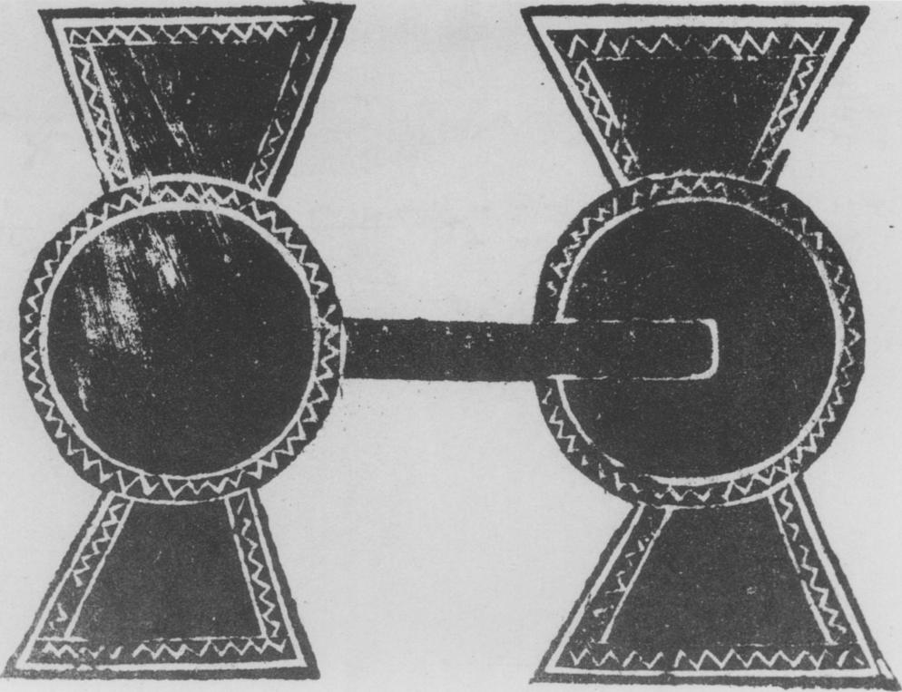

Fig. i. *Sheng* from *Jin shi suo du ji* vol. 4.

|  |  |  |  |  |  |  |  |  |  |  |  |  |  |  |  |  |
| --- | --- | --- | --- | --- | --- | --- | --- | --- | --- | --- | --- | --- | --- | --- | --- | --- |
| it  • ; •  Of"  Fig. 2. Pictorial brick from Xinye, Henan. After *Kaogu xuebao* 1990.4, 503, fig. 3:z. | | |  | | III | | | |  | | | | ,.  / | | | |
|  | | | |
|  | | | ---....,./ | | .. | :  Off II | | | | i+' . | | | | , ii• ' It  **ginr**  **1$.**  **1/41.1** | |  |
|  |  |  | **. trr--** | **Ni.**  **...**  ***ts***  **1.1n,) "** | | |  | | | |  |  | | |  | |
| **1,- "411114110:0'** | | | | | | | |  | | | |  | | |  | |
|  | | | | | | | |  | | | |  | | | | |

Fig. 3. Detail of ceiling in tomb of Bu Qianqiu. Line drawing after *Wenwu* 1977.6, 62, fig. 17.

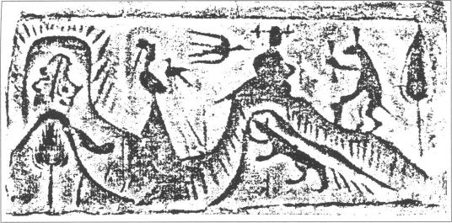

Fig. 4. Pictorial brick from Henan. After *Henan Han dai hua xiang zhuan* (Shanghai: Renmin meishu chubanshe, 1989): fig. 87.

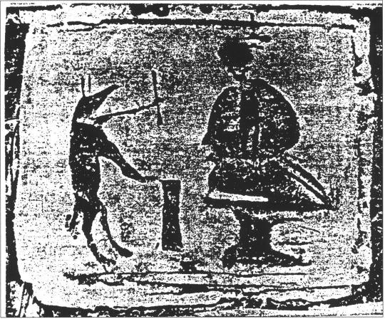

Fig. 5. Pictorial brick from tomb at Xintongqiao, Zhengzhou.

After *Henan Han dai hua xiang zhuan*

(Shanghai: Renmin meishu chubanshe, 1989): fig. 88.

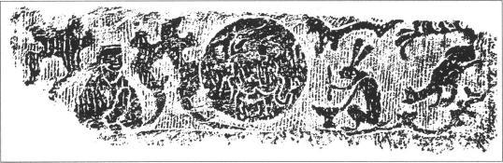

Fig. 6. Pictorial stone from Nanyang. After Sun Wenqing, *Nanyang Han hua xiang hui can* (Nanjing: Jinti dagong Zhongguo wenhua yanjiusuo, 1937): fig. 134.

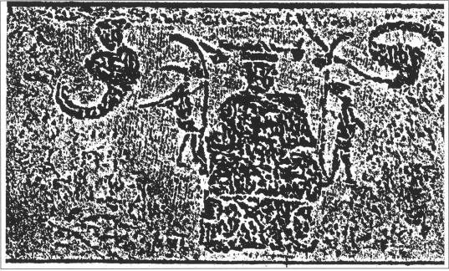

Fig. 7. Pictorial stone from Nanyang. After *Nanyang Han dai hua xiang shi* (Beijing: Wenwu chubanshe, 1985): fig. ,8z.

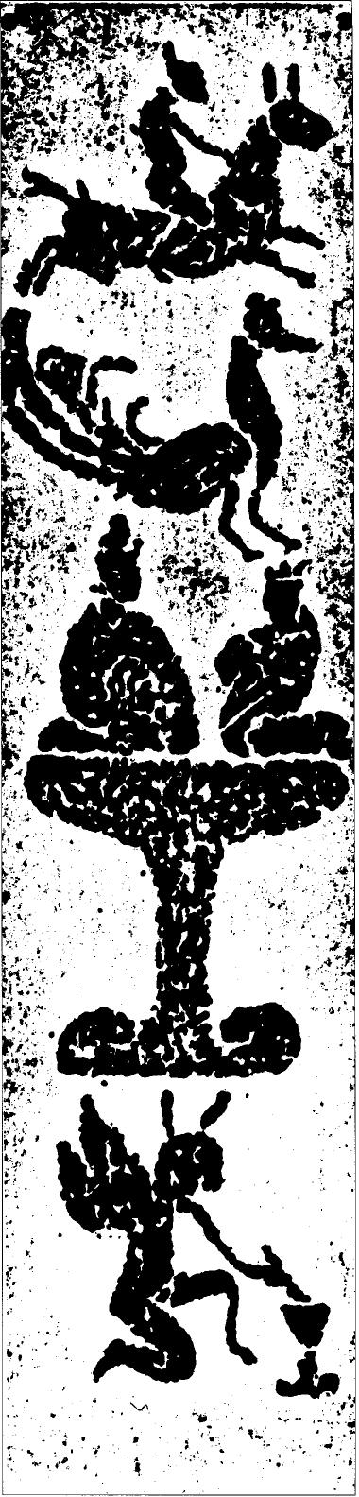

Fig. 8. Pictorial stone from Nanyang.

After *Nanyang Han dai hua xiang shi* (Beijing: Wenwu chubanshe, 1985): fig. 332.

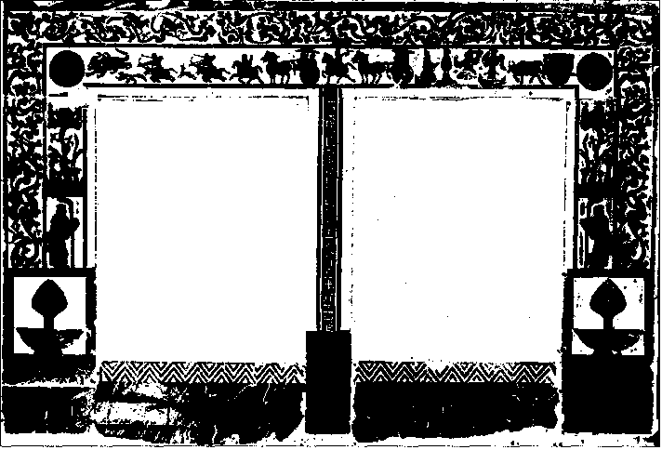

Fig. 9. Inner doorway, tomb at Suide, Shaanxi. After *Wenwu 1983.5,* 3o, fig. 3.

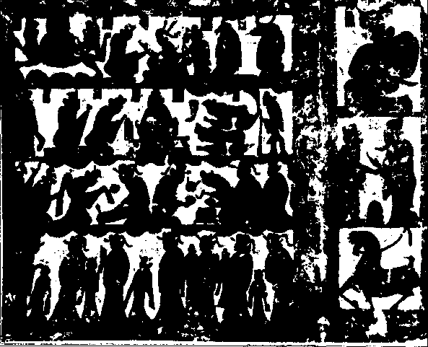

*Fig.* To Pictorial stone from tomb near Xuzhou. After *Wenwu* 1990.9, *66, fig.* 2.

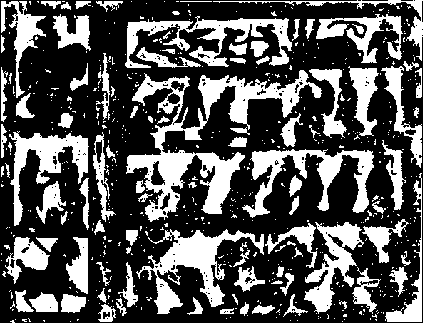

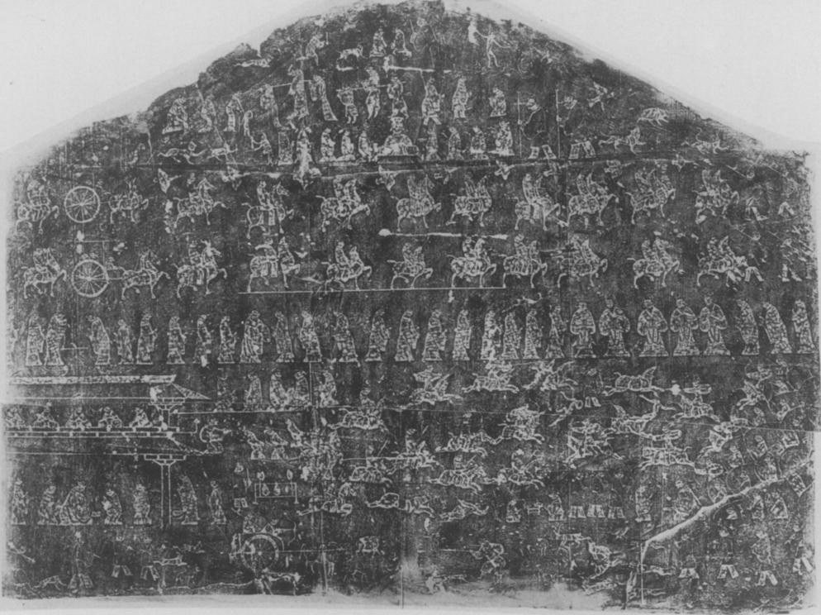

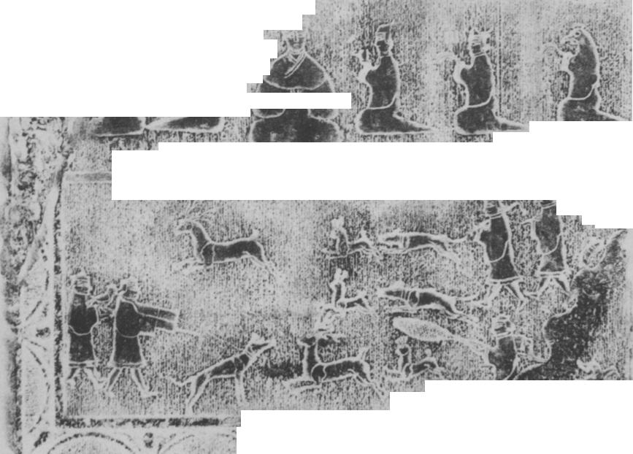

Fig. 12. East wall *(paroi orientale),* Xiaotang Shan shrine. After Chavannes, 1913, vol. i, figs. 47 and 5o combined.

t, , 0.4.... -

.., • 4 *bt* 1

**.1. !, n••**

**14' "VY "r•**

r. s.L.;,11,,... • ' ". f • .• • ,.. n . **oL. '. 3 ••• .**

**1.ire - 4'., ••n•- - 1,,oxelfgofiA.'11,f ? ik, it.t:-dr , *'Woe.* illt'ur‘-ittVe- 44A. : ,:, .4441130.10*4-....:". ',I'M:1,4 *tr.'..* 4 , !,... *to!* Mt..**

**it**

**! :1.4nC :', : ' 1. . • , .., - „.„4,,,,,,, ... . 4.. : •••, . a**

**Nit/ 1.** rie ,,lik:l..71:4•:;'. ' -'' • -

. • ***. 1***

, :•,4,"•irr)i.t,ir! I"-

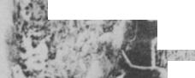

. :. V :- • 'i,.. , -. ..

**n'**

* ii- • ',.t.,Ii .

:.; i la, •,,

t.*sir* **(4.t.' 7,11(1. 117,%.:1114:1&:.,1 • •; 01•..4•\**

**r , , •••••,. ' 7**

* **" . • • • : • - —••••• soi,s" %.•**

***1,44P.***

**!N •**



**4. 4**

**ri P.3**

**tbryr,s,mtit. t 41.4WOO.% AZ4 /VFW 4111441;r4WIP`**

**,** f

**4fn '**

**•••**

•

•

Fig. 14. West wall, shrine of Wu Liang. Courtesy of the Field Museum of Natural History, Chicago. Photograph by author.

***• .t5ArCe,,,;ir***

***WavO_IIIImMINE614sigrwuzsaist assauissza:tzsliatzerwi***

**. • “Y**

**. of *wilf-X27r***

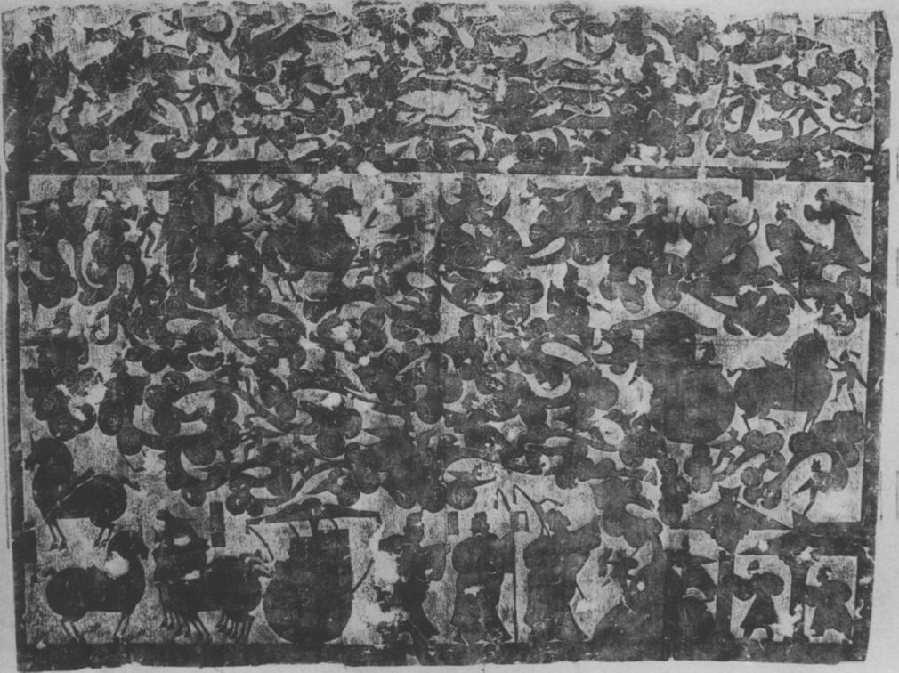

Fig. 15. Ceiling stone from Left shrine of the Wu family.

Courtesy of the Field Museum of Natural History, Chicago. Photograph by author.

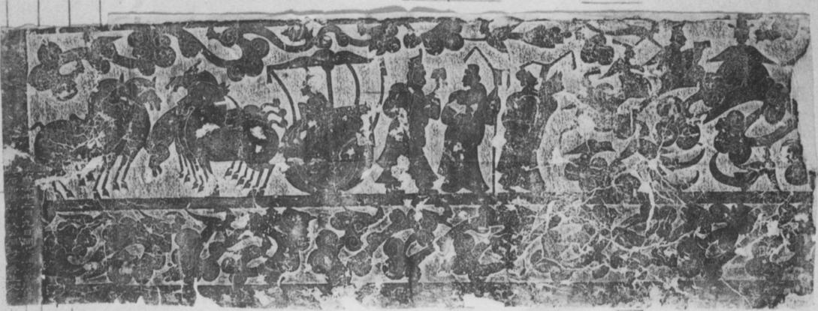

Fig. 16. Pictorial stone from the Wu shrine atelier. Courtesy of the Field Museum of Natural History, Chicago. Photograph by author.

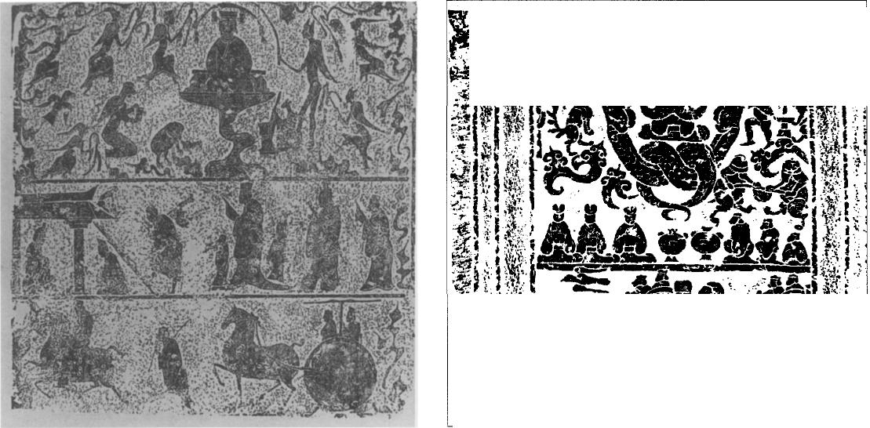

Fig. 17. Pictorial stone from a small offering shrine. Fig. 18. Pictorial stone from Shandong.

i.i,oko-.- 470,tieorv...1giikAV:.4•%rit 4fL-.1e •,10:.i41-•;,-:.:1,41Va1.-1.:-.7r-...•1 Laa ..:qsmr7.P.T.,....samlwwoIPIPst,;:swnit4"sr'aa6r"""""q"•:PK•wamH. ...—.......44......: :::.;sray....f" '...".".."::;"'.::.

Wti7k., , , ...,„*.•;•• , --4,.....:,.. . • .. • A . , . . . 1 , i  
4wrA1witAverreariorraseer. *w..arsinsiimossi*

4-31. **il ar**

**.** ,

**..mawkale*Abl4.,41.1ftem.csmalr011.10911iwal**j

**•**

* **' 4.410. •** r. . •

After *Wenwu* 1979.9, 3, stone 4. After *Shandong Han hua xiang shi xuan ji*

(Shandong: Qilu shushe, 1982): fig. 219.

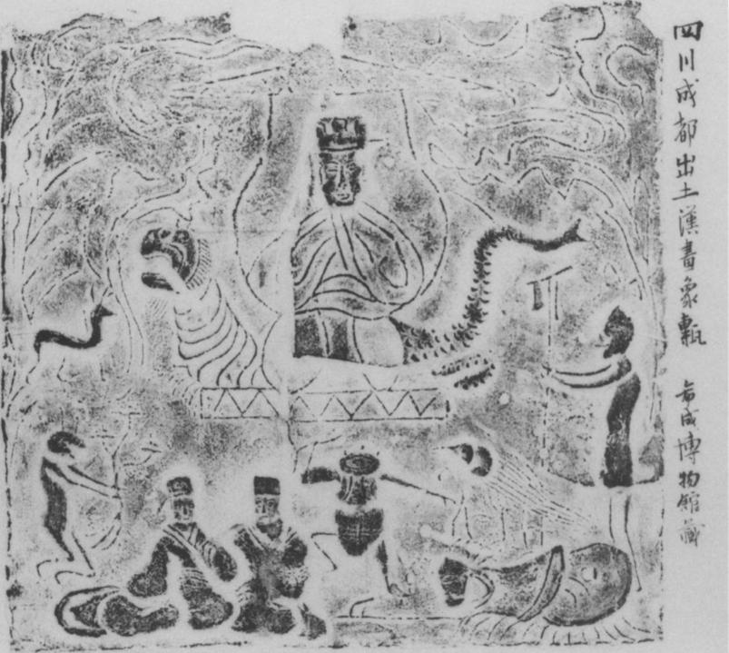

Fig. 19. Pictorial tile from Sichuan. Courtesy of the Field Museum of Natural History, Chicago. Photograph by autnor.

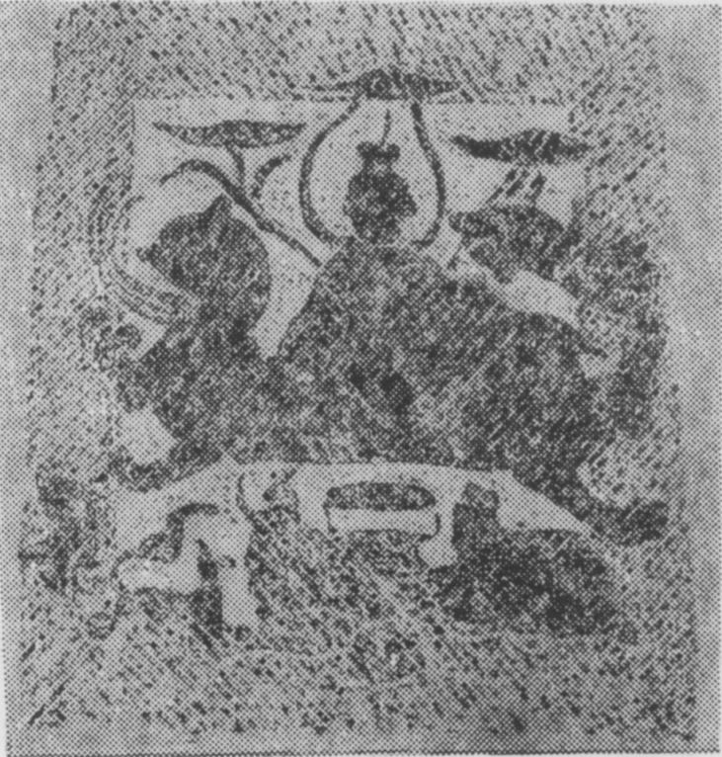

Fig. zo. End of stone coffin from Sichuan. After *Kaogu* 1979.6, 5oz, fig. 13.

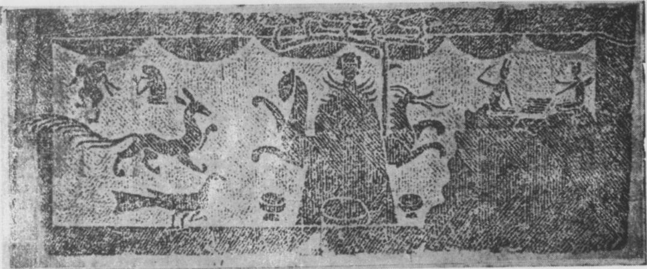

Fig. 21. Side of stone coffin from Sichuan. After *Kaogu 1979 .6 ,* Soo, fig. 1o.

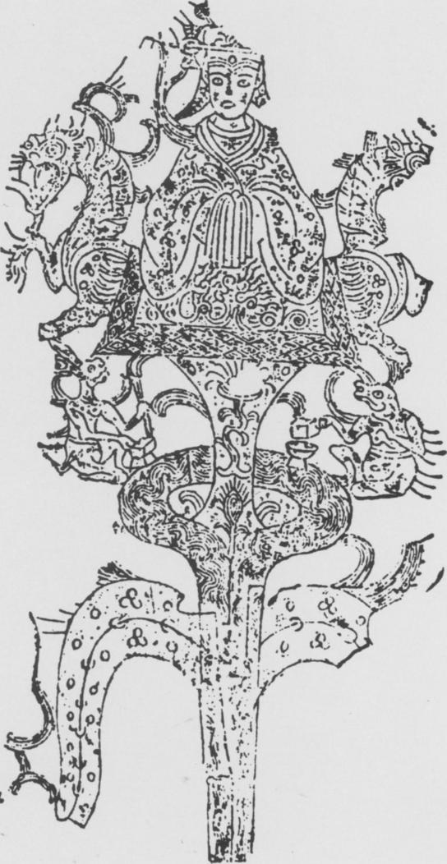

Hsio-yen Shih in 1959 need further analysis, as do the dates given to it, A.D. 193 in the site report but 280-310 according to Shih.43 The role of guardians of the tomb entry given to Xiwangmu and Dongwanggong here, where, unlike the Shaanxi tomb door there is no pictorial reference to the soul of the deceased, points to the change in the role of the two deities to come in the future.

As we have seen, during the second century A.D., artists in Shandong depicted Xiwangmu in sev­eral ways; as a cult figure of a benevolent deity (figs. 12 and 13), as the embodiment of the *yin* force (figs. 13 and 17), and as ruler of a paradise on Kunlun visited by the traveling *hun* soul (figs. 15,16, and 18). This remote paradise will, in time, be conflated with the Western Paradise of Amitabha Buddha.

Xiwangmu in Sichuan

In Sichuan, Xiwangmu was worshipped as a deity to whom one could pray for the *bun* soul of the departed, a belief illustrated on the much earlier pictorial brick from Xinye, Henan (fig. 2). Scenes on pictorial tiles from second-century A.D. cave tombs in Sichuan and on the ends of stone coffins show suppliants praying to her. Another role is given to her in Sichuan, that of the giver of good fortune, especially money. In this role she and her two guardians, the tiger and the dragon, sit at the apex or on the branches of objects called "money trees" (fig. 22).

The frontal pose, described previously as that of a cult statue, is always used in Sichuan as far as we know to date. The influence of Buddhist art in Sichuan and the adaptation of the Buddha image to frontal iconic images of Xiwangmu has been posited by Wu Hung, who further has noted a number of parallels between the two deities; both the Buddha and Xiwangmu possessed "supernatural powers and...were able to assist people. They were cosmic figures connected with the sun and moon, they both abided in a remote western land, believed to be paradise by the Eastern Han Chinese."44

Large, square, mold-made pictorial tiles set into the walls of tombs in Sichuan present Xiwangmu as ruler on Kunlun (fig. 19). She sits on a mat, a canopy above her to represent the sky and symbolize her rank as queen. Clouds float around the canopy. The dragon on her left and the tiger on her right guard her throne. They are always shown in profile, looking to left and right, and frame the figure of Xiwangmu, who is always shown *en face.* The maker of the mold for this tile put the nine-tailed fox at the left, the hare below it. This hare holds a stalk, rather than a pestle and no mortar is to be seen. Two persons, possibly a man and wife, sit at the lower left. A rather odd figure, perhaps a dancing toad, performs between them and the suppliant at the lower right. This figure, kowtowing to the couple at the left, could well represent the filial son offering prayers to Xiwangmu for the benefit of his deceased parents. A three-legged bird, representing the three birds who bring food to Xiwangmu, and an emaciated guard, presumably a *xian* residing on Kunlun in the service of Xiwangmu, complete the scene. This tile is one of a number excavated near Chengdu before World War II, many of them published by Richard C. Rudolph in *Han Tomb Art of West China* (1951).

A similar layout was used by the carver of one of a group of stone coffins excavated in Sichuan (fig. 20) and dated to the second century A.D.45 The carving is rough and the figures are just barely legible. A tree with two branches, possibly the *ruo* tree that grows on Kunlun flanks the canopy above

43 Zeng Zhaoyu, Jiang Baogeng, and Li Zhongyi, *Yi'nan gu hua xiang shi mu fajue baogao* (Beijing: Wenwu chubanshe, 1956): 193; Hsio-yen Shih, "I-Nan and Related Tombs," *Artibus Asiae* zo, no. 2 (1959): 297.

44 Wu Hung, *Orientations,* 33.

45 "Pictorial Stone Coffins in Eastern Han Brick Tombs at Pixian, Sichuan," *Kaogu* 1979.6: 502 (in Chinese).

Xiwangmu.46 She sits on a mat with a rather bulky pair of guardians; the dragon has its head turned back to allow it to fit in the space available. The fox is at the lower left, a suppliant at the lower right. A barely discernable hare sits in the middle. The tree/canopy frames the head of Xiwangmu and the two branches with parasol-like tops are above the heads of the dragon and the tiger.

On another coffin in this group Xiwangmu is shown on the long side, seated on what appears to be the top of a mountain (fig. 21). The trunk of a tree is at her left, its five branches spread above her to make a canopy. The dragon and tiger look alertly to left and right. Her other companions, the hare, toad, fox, and bird, line up at the left. Three bowls for offerings are placed before her. At the upper right two winged *xian* play the board game called *liu bo* while seated on top of another mounting. The entire scene represents Kunlun, the desired destination of the *hun* on its way to heaven.

The Xiwangmu in Sichuan tomb art is the beneficent deity who rules on Kunlun. The faithful pray to her image for help for the *hun* soul and are shown doing so. The cosmic role given to her in the funerary monuments of the upper class, such as the Shandong offering shrines, does not appear. She is a deity for ordinary people and in Sichuan her function as a personal deity is foremost for she has a role to play in the lives of the living as well as the afterlife of the dead.

Xiwangmu and the World of the Living

The images of Xiwangmu on mirrors and money trees have meanings different from images of her in funerary art. The gifts of long life and prosperity she can vouchsafe to her followers, described in the Yi *Lin,* are denoted in inscriptions on mirrors and the imagery of the money tree.

A few Han mirrors carry images of Xiwangmu and Dongwanggong along with inscriptions wherein the desire for long life is clearly expressed. Such inscriptions are charms to insure the longevity their words invoke. Karlgren cites two such inscriptions that are of particular interest: "May your longevity be like Dongwanggong and Xiwangmu;" "May you, like Dongwanggong and Xiwangmu, be preserved as long as heaven."47 Karlgren and Loewe read the images of the two deities on Han mirrors as talismans of cosmic bliss adapted for decorative use on mirror backs.48 Mirrors are objects owned by the upper class but money trees were surely made for the mercantile middle class.

Money trees are a new and different context for images of Xiwangmu. These objects are cast in bronze; the trunks are set into stone or ceramic bases. A very fine intact example excavated in Guanghan county, Sichuan, adorns the cover of *Orientations* (April, 1987), and is discussed by Wu Hung. On the ceramic base an animal crouches on top of a hill. Out of its back grows the thin cylin­drical trunk of the tree. The branches are attached by pins fitted into slots on the trunk; there are five clusters of four branches each. Each branch carries the flat figure of Xiwangmu seated on a mat, guarded by the tiger and dragon, with a canopy overhead. The figures of animals and entertainers accompany her on the various branches. Each branch bears a number of coins, hanging down as if they were flowers. At the very top of the tree stands *a ftnghuang* bird, its wings spread. This bird is a good omen symbolizing peace and prosperity.49 The coins represent wealth, which most people

46 See *Shan Hai jing* 17/8a, 18/3b, and *Huainanzi* 4/3a.

47 Bernard Karlgren, "Early Chinese Mirror Inscriptions," *Bulletin of the Museum of Far Eastern Antiquities* 6-7 (5934): 48.

48 Karlgren, "Early Chinese Mirror Inscriptions," 63; Loewe, *Ways to Paradise,* 88.

49 **q":** Jan, vol. 1: 335-36.

would agree is highly desirable. The Xiwangmu on the money tree is the goddess her devotees prayed to for rescue from hunger, from drought, and from danger as recorded in the *Han Shu* and Yi *Lin.*

The remains of a money tree excavated in Sichuan in 1976 (fig. 22) were found in an Eastern Han tomb.5° The piece is made of bronze and the figures are flat, not modeled in the round. The details are in linear relief. The surviving upper portion is 27 cm long and 13.5 cm across at the widest point. Xiwangmu's gown closes on the left in the manner of the western non-Chinese pastoralists to indicate that she lives beyond the Han borders. Her figure seems to lack legs, as there is no indication of them on the floral patterned mat beneath her. She is accompanied by her guardian dragon and tiger and her acolytes, the hare and toad. The remnant of another dragon is attached to the trunk below the figures. No "coins" have survived but two small dragon heads belonging to this piece were found with the money tree.

The creator of this piece took the frontal pose and adapted it to the requirements of this object. The figures occupy what would be a square space if they were framed. The oval shape seems to terminate the trunk of the tree. Xiwangmu's features are quite appealing; rendering her image in metal rather than brick or stone makes a much more delicate depiction of her features possible.

Conclusions

The archaeologically recovered bricks, stones, and money trees, combined with the texts, espe­cially the Yi *Lin* and the *Han Shu,* tell us that the cult of Xiwangmu had its origins sometime during the first century B.C. and was widespread by the first century A.D. She was a figure of popular religion and, by the late second century A.D. was incorporated into the cosmological scheme devised in Shandong for use in offering shrines built for the upper class Wu family. This scheme was followed in the decoration of other shrines produced by the Wu shrine artists. Xiwangmu, cosmology notwithstanding, never lost her original role for she was essentially a personal deity, a benevolent goddess to whom one could pray for wealth, a long life, and who could assist *hun* souls. After the influx of Buddhism following the fall of Han in A.D. 220, she left her home on Kunlun and its paradisiacal ambiance to the Buddha Amitabha and his Western Paradise, and became a Daoist deity, popular among Tang poets and common folk. She became so popular that her cult was regarded as subversive of domestic order.51

The creation and development of the image of Xiwangmu, her attribute of the *sheng,* her com­panions and her role in funerary art, in both tombs and offering shrines, reveals that Chinese artists were fully capable of devising an identifiable icon to present commonly-held ideas and beliefs about a specific deity. Xiwangmu as a deity of Han folk religion came into being in response to the need of common folk for a personalized deity, a power to whom they could pray for aid. We do not know how this need arose, but the Yi *Lin* and *Han Shu* descriptions of her and of the activities of her followers prove that such a need did exist. Han artists created an icon, a religious image with attributes, which led the minds of the devout to ponder the powers of the deity represented and the significance of those powers in the life of the devotee. The cult of Xiwangmu arose just a few years earlier than the rise of Christianity in the Classical world. In both cases, artists had to create icons and all attributes

50 Liu Shixu, "Pieces of a Han Chinese 'Money Tree' Excavated in Gaozao, Xizhang, Sichuan," *Kaogu 1987.3:* 29-8o (in Chinese).

51 Suzanne Cahill, "Beside the Turquoise Pond: the Shrine of the Queen Mother of the West in Medieval Poetry and Religious *Practice," Journal of Chinese Religions 12* (1984): 31.

that give icons their individual identities. The needs of the people during the early centuries A.D. in the Roman and Han empires were similar; ordinary folk needed solace and reassurance in times of trouble, comfort in life and hope for an afterlife free of pain. Help was sought from personal gods, saviours, in fact, presented in proper doctrinal anthropomorphic form. Even though Xiwangmu was shunted over into religious Daoism, her place as savior taken by the Buddha, her irruption into Han China's world, which did, after all, lack any down-to-earth deities, is important because she was the very first deity to appear in Chinese religion outside the state cult devoted to sky gods like Tai Yi.sz Hers is the first devotional icon to appear and it was supreme until displaced in both form and function by the Buddha image and Buddhism.

The art of Han China is replete with figures, narratives, stories of famous men and women of the past, activities of daily life of all sorts, guardians, and sky dwellers but there is only one deity, and that is Xiwangmu; Dongwanggong is only an appendage.

52 Loewe, "K'uang Heng and the Reform of Religious Practices (31 b.c.)," *Asia Major 17 (1971): t-27.*

**GLOSSARY**

**Bu Qianqiu F .T.t)( *bu si yao***

**Changhe**

**Chang'o** X5t

**Chi Songzi Z-t\b,T­Cui Zhuan *iF**

**Di Jun lYiR Dongwan 14: ong**

***guan***

**Guanghan /IX**

***hun***

**Jiao YanshouiE**111# **Kunlun tit**

‑

***Bu bo***

**Mawangdui**

**Peng Zu** Sim ***po***

***qilin***

***ruo*** g

**Ruo shui** *

***shan 111 sheng***

**Tai Yi (—)**

**Wang Zicliao**

**Wu Liang**

**Xi He fliffi**

***xian 111***

**Xiaotangshan *I Lit Xiwangmu a**  
**Xuzhou ti),1,1**

***yang I\****

***Yi Lin*** *g#*

**yin**

**Ziweigong** g